Тема урока: «Мои выходные в кругу семьи»
Тип урока: обобщение и систематизация знаний;
Формы работы: фронтальная, индивидуальная, групповая
Цель урока: закрепление в устной речи материала по теме: «Простое прошедшее время».
Задачи урока:
Обучающие:
- формирование грамматических навыков по теме «Past Simple Tense».
Воспитывающие:
- развивать положительную эмоциональную направленность на учебную деятельность;
- формировать ценностное отношение к семье и семейному досугу.
Развивающие:
- развивать память, внимание, языковую догадку;
- способствовать формированию рефлексивно-оценочных навыков;
- развивать способности анализировать и обобщать;
- развивать творческое воображение у школьников.
Личностные УУД: формировать ценностное отношение к семье и семейному досугу.
Регулятивные УУД: планировать свои действия в соответствии с поставленной задачей, адекватно воспринимать оценку учителя и товарищей.
Познавательные УУД: развивать умение выстраивать логическую цепочку рассуждений для дальнейшего выполнения соответствующих действий.
Коммуникативные УУД: построение речевого высказывания, продуктивное взаимодействие и сотрудничество друг с другом.
Лексический материал: played computer games, skated, skied, listened to music, watched TV, walked in the park, stayed at home, cleaned the room, cooked dinner, helped parents, painted the picture, visited grandparents.
Оснащение урока: учебник «Spotlight» Быкова 4 класс часть 1, проектор, экран, компьютер, карточки.
План урока:
- Организационный момент
- Речевая разминка
- Фонетическая разминка
- Определение темы и цели урока
- Актуализация знаний
- Физминутка
- Закрепление материала
- Рефлексия
Ход урока

- Орг. момент | Hello, pupils! I am glad to see you. Today I am your teacher. My name is Olga Sergeevna.
- Речевая разминка | Let's meet. What is your name? How are you today?
- Определение темы и цели урока | Look at the screen, please. What can you see?  You can see the family with the balloons. These balloons help us to learn the topic of the lesson, but at first, you should answer the questions.  1. What is the first day of the week in GB?  2. What is the 2 - 7 day of the week?  Now we have different letters, take yellow cards and make up the word.  We have two key words:  weekends and family. Look at the picture attentively and say what is the topic of our lesson?  What will we do at the lesson today?  The aim of the lesson is to make up the stories about last weekends. | Слайд 1  Карточка  Слайд 2  Тема урока на доске
- Фонетическая разминка. | Let’s train our tongues. В стихотворении встретится буквосочетаниеTH, в данных словах оно читается звонко. Кончик языка ставим между передними зубами и выдыхаем с голосом.  Last Sunday my mother skated,  Last Monday my father painted,  Last Wednesday my brother stayed at home,  Last Friday I listened to music alone.
- Введение материала | Now let's through the active vocabulary of our lesson.  Take your lists with words. Listen and repeat the words after the speaker.  The next task. Take cards № 1 and make up the word combinations. For example: to visit grandparents.  You have got 4 minutes.  play computer games  listen to music  watch TV  walk in the park  stay at home  clean the room  cook dinner  help parents  paint the picture  water the flowers  Check the task. Go to the blackboard and make up the word combinations.  Now let's read the word combinations.  The aim of our lesson is to talk about the last weekends. What time we should use for it?  Children, tell me please, what end's form is used for last weekends?  Как образуется прошедшая форма глаголов в английском языке?  Now the next task.  Take cards № 2 with different verbs, find out them.  You have got 2 minutes.  p l a y e d h e l p e d  w a t e r e d x x a f f  a p a i n t e d z i z s  l i s t e n e d r n r t  k v i s i t e d h t f a  e b x v c l e a n e d y  d c l m c o o k e d f e  w a t c h e d n t t n d  played  listened  watched  walked  stayed  cleaned  cooked  helped  painted  visited  watered  Check the task, go to the screen and find out the verbs.
- Физминутка | Let's have a rest.  This finger is my grandfather  This finger is my grandmother  This finger is my father  This finger is my mother  This finger is me  These are my family.  This finger is my aunt  This finger is my brother  This finger is my sister  This finger is my cousin  This finger is me  These are my family.
- Закрепление материала | The next task. Take the cards № 3. Read the text, look at the pictures and complete it.  You have got 10 minutes.  My name is Mag. I have got a big family. I have got a mother,… .  Last weekend we visited our ____________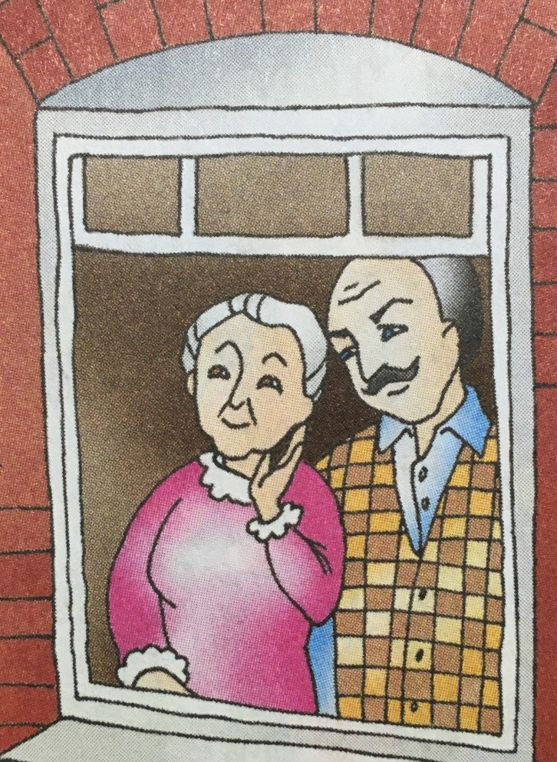 .  On Saturday we helped our 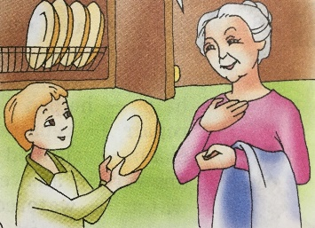.  We ____________ 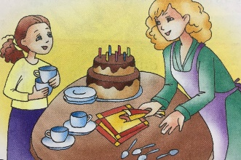. My brother Alex ____________  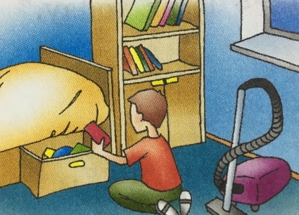 .On Sunday our family had fun. Our grandfather ____________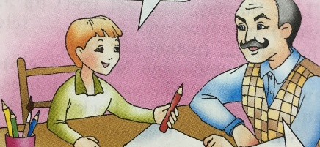for Alex. The father 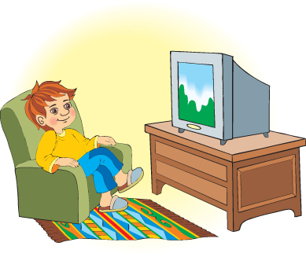 . My 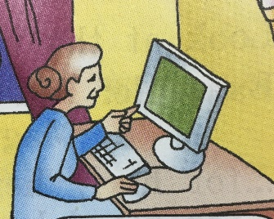. I love our family weekends.  Let’s check, read the text.  Now let's imagine: you are the different families.  You are Black s family. You are Wilsons family. You are Browns family. Choose the card and make up some sentences about your last weekends.  For example: I am a grandfather. My name is Pete. Last weekends I walked in the park.  Now check the task. Lets start with Black s family.
- Рефлексия | If the lesson was interesing choose an orange smile and put it on the blackboard.  If the lesson was boring choose a green smile and put it on the blackboard.
- Подведение итогов | Thank you for your work! You were very active today. I hope that you will remember our lesson. And I want to give your little presents. The lesson is over, good byе.

